PJ B1 – REVERSE
TOPIC
B1
ENGINEER A SYSTEM

TIME TO COMPLETE: 2 HOURS

PART 1: PROBLEM STATEMENT
We are surrounded in today’s world by systems so complex them seem to defy understanding. Self-learning AIs, social media algorithms trained to learn your interests, and the marvel that is the world wide web are just a few examples.
Sometimes, the best way to explore the creation of systems is to try to break down a pre-existing system to understand its structure. When we look at a system from this ‘black box’ perspective, we aren’t told much, so we must do a bit of inference.
For this project, I want you to select an existing product or service, and break it down into its subcomponents, isolate and analyze the problems that it is intended to solve, and report this information in a presentation to the class.
PART 2: REQUIREMENTS
- Select an existing product or service. I will be using YouTube as an example of a service throughout this document.

- Determine what problem that product or service is meant to solve (YouTube – it is difficult to find and share user-generated videos on the internet)

- Identify the stakeholders in the product or service (YouTube – Viewers, investors, content-creators)

- Identify the constraints & limitations of the product or service (YouTube – requires strong enough hardware to decode video, internet bandwidth, cost of video hosting/streaming, ensuring content on the site is legal/moderated)

- Identify some goals & objectives of the product or service (YouTube – Videos are viewable across multiple devices, the site recommends videos to viewers that are based on their viewing habits, videos are simple and free to upload, users can start watching videos in fewer than 3 clicks

- Identify some of the input & output that the product or service has (YouTube – Input: Video files, video metadata, user clicks, user searches – Output: Video stream, audio, video metadata, video recommendations)

- Decompose your product or solution into 5 subsystems/algorithms, and explain what they do and how they talk to each other (YouTube – Recommendation algorithm talks to the History/Engagement system, which talks to the Input system (for registering clicks on videos))

- Attempt to reverse engineer two algorithms from the product/system and depict them as a flowchart . You do not need to know how exactly they work, just attempt to do what you think it is.
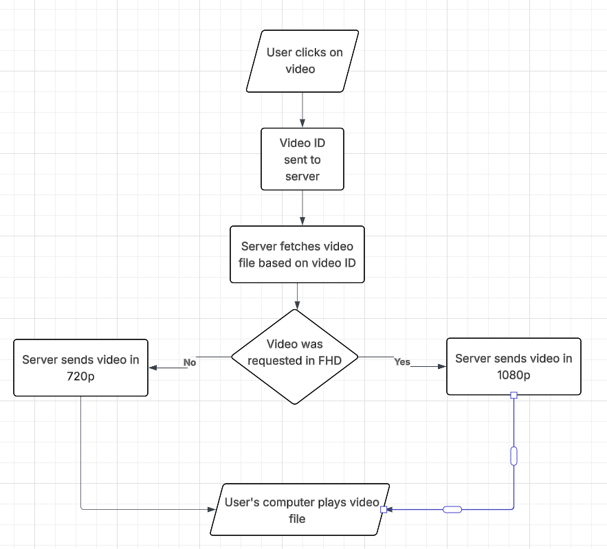

- Finally, compile all of this information in a 10-15 minute powerpoint/slides presentation that we will present at the end of the next handful of classes. You do not need to turn anything in other than the powerpoint with all of these questions answered therein. The slides should be visually engaging and flow well.

PART 3: RUBRIC

Information | All info from part 2 is included in sufficient detail | 70
Presentation | Talk good (be prepared) | 10
Participation | Not being disruptive and asking good questions during other people’s presentations | 20

